iPad Apps
The following SAM-based programs have iPad Apps:
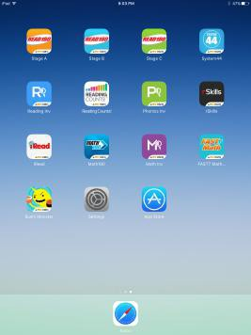
Read 180 Universal
System 44 Next Generation
Reading Counts
iRead
Math 180 Course
FASTT Math Next Generation

After downloading the App from the App Store, it must be configured to connect to your server. Each App must be configured.

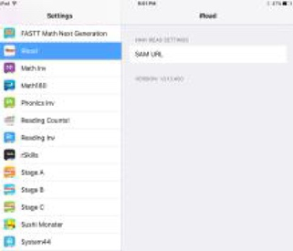
1. Tap Settings
2. In Settings, scroll down on the left until you see the Apps listed.
Tap the first App to be configured.

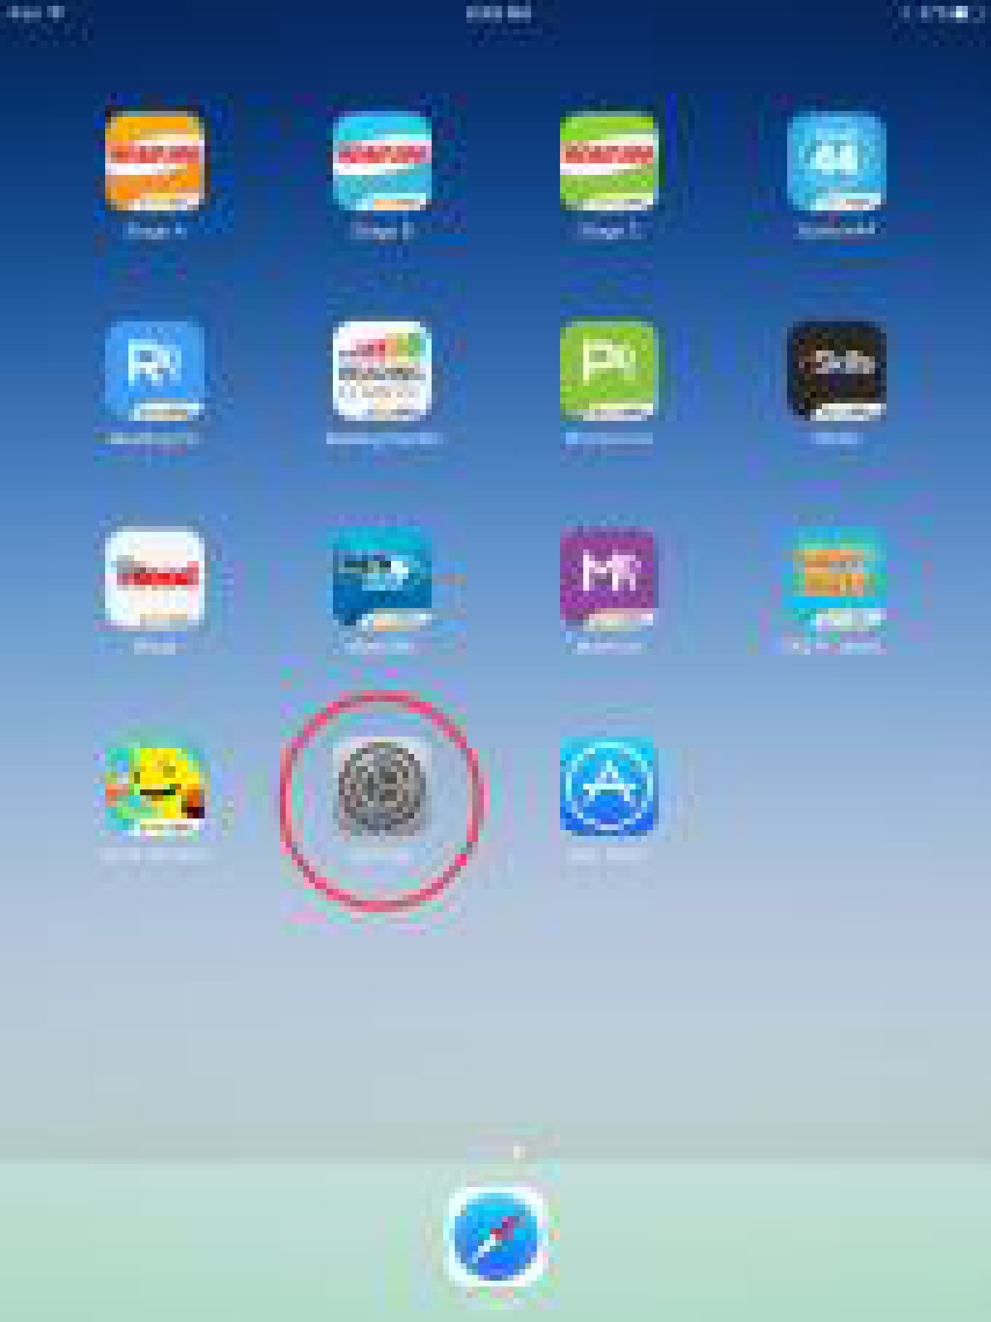

3. On the right, enter the Site ID for the server you are using (if entering a Hosted Sever Site ID be sure to enter the correct number of zeros).
- Elementary: h100000058
- Middle: h100004008
- High: h100003989

4. Tap on the next App and enter the Site ID again for that App. Each App needs the Site ID set.

5. If a configuration error comes up when the App is launched, the Site ID is not set correctly. Go back into Settings and enter the Site ID for that App again.

6. If an App prompts for access to the microphone, tap Allow (Read 180 Universal, System 44 NG, and iRead have student recording activities).

